HTML & CSS - Exercises

1. Headers 2

2. Paragraphs 3

3. Order and Unorder Lists 3

4. Links 4

5. Images 4

6. Table 4

7. Forms 4

8. Tag Cardio: Text Formatting 5

9. Tag Cardio: Inline Elements 5

10. Tag Cardio: Block Elements 5

11. CSS Basics: Inline Styles 5

12. CSS Basics: Internal Styles 5

13. CSS Basics: External Styles 6

14. CSS Selectors: Class Selector 6

15. CSS Selectors: ID Selector 6

16. CSS Selectors: Universal Selector 6

17. CSS Selectors: Grouping Selector 6

18. CSS Selectors: Descendant Selector 7

19. CSS Box Model: Margins 7

20. CSS Box Model: Padding 7

21. CSS Box Model: Borders 7

22. CSS Box Model: Width and Height 8

23. CSS Layout: Positioning 8

24. CSS Layout: Float 8

25. CSS Layout: Flexbox 8

26. 8

27. CSS Layout: Grid 8

28. CSS Layout: Media Queries 9

29. CSS Typography: Font Family 9

30. CSS Typography: Font Size 9

31. CSS Typography: Font Style and Weight 9

32. CSS Typography: Text Alignment 9

33. CSS Typography: Text Decoration 10

34. CSS Typography: Line Height 10

35. CSS Colors: Background Color 10

36. CSS Colors: Text Color 10

37. CSS Colors: Border Color 11

38. CSS Background: Background Image 11

39. CSS Background: Background Repeat 11

40. CSS Background: Background Size 11

41. CSS Background: Background Position 11

42. CSS Pseudo-classes: Hover 12

43. CSS Pseudo-classes: Active 12

44. CSS Pseudo-classes: Focus 12

45. CSS Pseudo-elements: Before 12

46. CSS Pseudo-elements: After 13

47. CSS Pseudo-elements: First-line 13

48. CSS Pseudo-elements: First-letter 13

49. CSS Transitions: Basic Transition 13

50. CSS Animations: Keyframes 13

51. CSS Flexbox: Responsive Navigation 14

# Headers

Create a Web Page like the following and use six different HTML headings:

Create a file named headers.html. Set the HTML title to be the same as the task name.

# Paragraphs

Create a Web Page like the following, using <p>:

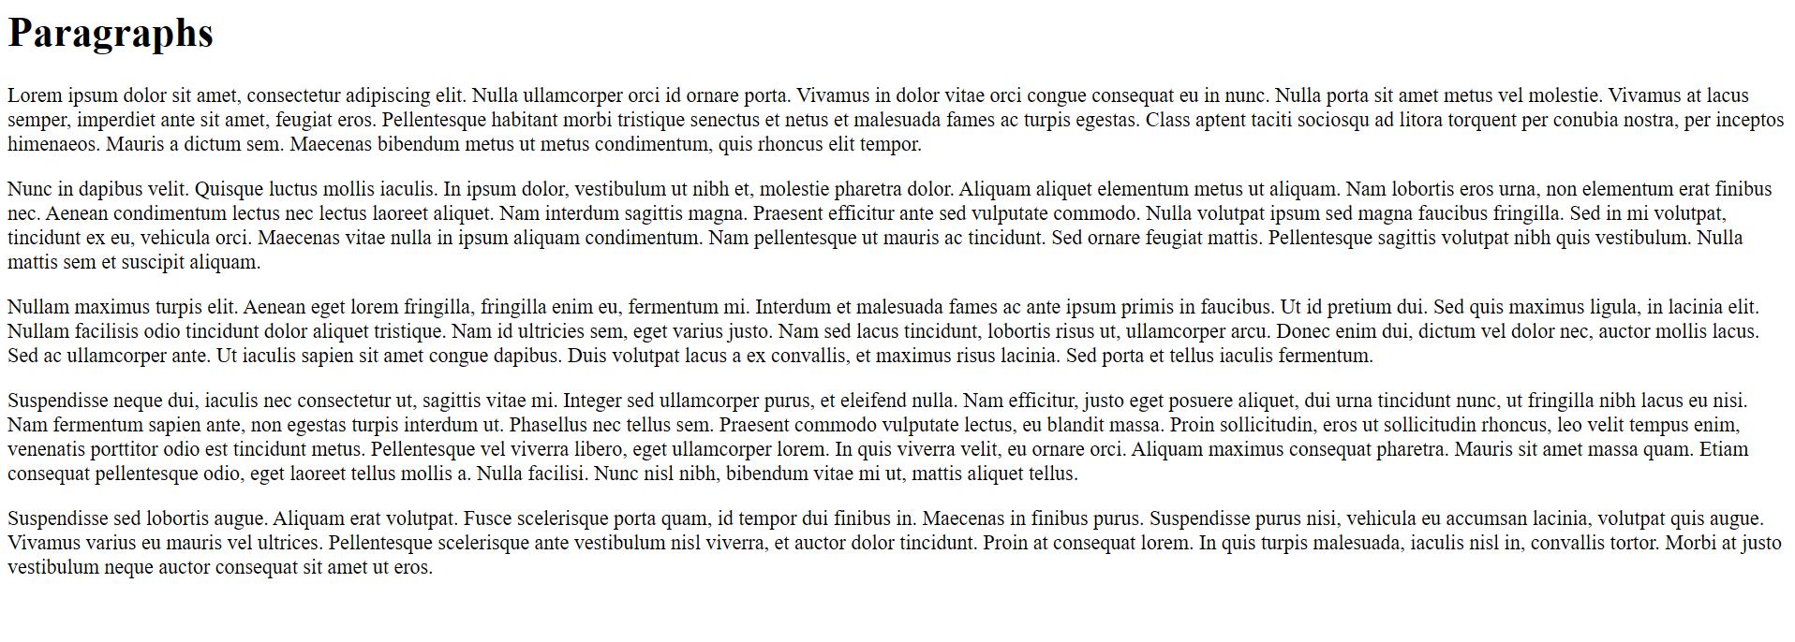

Create a file named paragraphs.html. Use some text you find in web or generate lorem ipsum text: <https://www.lipsum.com/>

Set the HTML title to be the same as the task name.

# Order and Unorder Lists

Create a Web Page like the following:

Use <ol>, <ul>, and <li>. You need to use lists nested into the list items from the upper level.

Create a file named nested-lists.html. Set the HTML title to be the same as the task name.

# Links

Create a Web Page with various links, using <a> tags.

Create a file named links.html. Include internal, external, and anchor links. Set the HTML title to be the same as the task name.

# Images

Create a Web Page that includes several images using <img> tags.

Create a file named images.html. Download some images from web and put them inside the images.html directory. Set the HTML title to be the same as the task name.

# Table

Create a Web Page that displays a table using <table>, <tr>, <td>, and <th> tags.

Create a file named table.html. Include a caption for the table. Set the HTML title to be the same as the task name.

# Forms

Create a Web Page with a form that includes text inputs, checkboxes, and a submit button using <form>, <input>, and <button> tags.

Create a file named forms.html. Ensure all form elements are appropriately labeled. Set the HTML title to be the same as the task name.

# Text Formatting

Create a Web Page that demonstrates text formatting using <b>, <i>, <u>, <strong>, and <em> tags.

Create a file named text-formatting.html. Use the text from Paragraphs task.

# Inline Elements

Create a Web Page that uses inline elements such as <span>, <a>, and <img>.

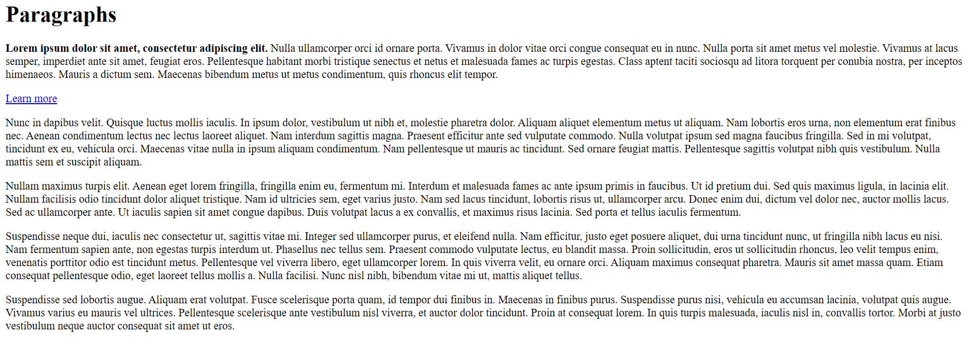

Create a file named inline-elements.html. Ensure proper use of inline elements within paragraphs.

# Block Elements

Create a Web Page that uses block elements such as <div>, <p>, and <h1>:

Create a file named block-elements.html. Ensure proper use of block elements within the layout.

# CSS Basics: Inline Styles

Create a Web Page and apply inline CSS styles to various elements.

Create a file named inline-styles.html. Style elements directly within their tags.

# CSS Basics: Internal Styles

Create a Web Page and apply internal CSS styles within a <style> tag in the head section.

Create a file named internal-styles.html. Redesign the previous task to use internal stylesheet rather than inline.

# CSS Basics: External Styles

Create a Web Page and link to an external CSS file to apply styles.

Create a file named external-styles.html. Create an external CSS file named styles.css. Set the HTML title to be the same as the task name. Redesign the previous task.

# CSS Selectors: Class Selector

Create a Web Page and apply styles using class selectors.

Create a file named class-selector.html. Use the class attribute to style elements with an external CSS file.

# CSS Selectors: ID Selector

Create a Web Page and apply styles using ID selectors.

Create a file named id-selector.html. Use the id attribute to style elements with an external CSS file.

# CSS Selectors: Universal Selector

Create a Web Page and apply styles using the universal selector.

Create a file named universal-selector.html. Apply styles to all elements on the page using an external CSS file.

# CSS Selectors: Grouping Selector

Create a Web Page and apply styles using grouping selectors.

Create a file named grouping-selector.html. Apply the same style to multiple elements using an external CSS file.

# CSS Typography: Font Family

Create a Web Page and demonstrate the use of different font families with CSS.

Create a file named font-family.html. Apply various font families to text using an external CSS file.

# CSS Typography: Font Size

Create a Web Page and demonstrate the use of different font sizes with CSS.

Create a file named font-size.html. Apply various font sizes to text using an external CSS file.

# CSS Typography: Font Style and Weight

Create a Web Page and demonstrate the use of font style and weight with CSS.

Create a file named font-style-weight.html. Apply different font styles and weights to text using an external CSS file.

# CSS Typography: Text Alignment

Create a Web Page and demonstrate the use of text alignment with CSS.

Create a file named text-alignment.html. Apply different text alignments to paragraphs using an external CSS file.

# CSS Typography: Line Height

Create a Web Page and demonstrate the use of line height with CSS.

Create a file named line-height.html. Adjust the line height of paragraphs using an external CSS file.

# CSS Colors: Background Color

Create a Web Page and demonstrate the use of background color with CSS.

Create a file named background-color.html. Apply different background colors to elements using an external CSS file.

# CSS Colors: Text Color

Create a Web Page and demonstrate the use of text color with CSS.

Create a file named text-color.html. Apply different text colors to elements using an external CSS file.

# CSS Colors: Border Color

Create a Web Page and demonstrate the use of border color with CSS.

Create a file named border-color.html. Apply different border colors to elements using an external CSS file.

# CSS Background: Background Image

Create a Web Page and demonstrate the use of background images with CSS.

Create a file named background-image.html. Apply background images to elements using an external CSS file.

# CSS Background: Background Size

Create a Web Page and demonstrate the use of the background-size property with CSS.

Create a file named background-size.html.

# CSS Pseudo-classes: Hover

Create a Web Page and demonstrate the use of the hover pseudo-class with CSS,

Create a file named hover.html. Apply hover effects to links and buttons using an external CSS file. Set the HTML title to be the same as the task name.

# CSS Pseudo-elements: First-line

Create a Web Page and demonstrate the use of the ::first-line pseudo-element with CSS.

Create a file named first-line.html. Style the first line of paragraphs using an external CSS file. Set the HTML title to be the same as the task name.